Reception Long Term Planning
SS John Fisher and Thomas More Primary School
Term | Topic | Key Texts | N.C Links | Key Learning
 |  |  |  | RE | Wider Curriculum
Autumn 1.a | All About Me | 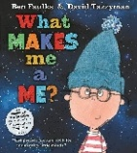  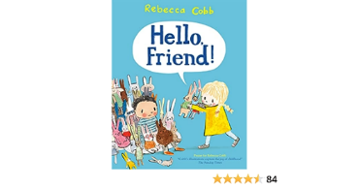  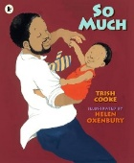 | PSHE  History  Art | RED Brand 1 Creation:  The words and actions of the sign of the cross: ‘In the name of the Father, and of the Son and of the Holy Spirit. Amen’.  God created the world and said, ‘Indeed it is very good’ (Genesis 1:31).  The whole of Creation shows God love for us (Laudato Si’ 84–88).  God is love.  God made each one of us.  God loves each one of us as a unique person.  God made a wonderful world and what God creates is good.  God loves us and we are part of a family.  We enter God’s family, the Church, through baptism | PSHE:  To adapt to a new classroom environment and build relationships with peers and staff  To understand that we all share similarities and differences as individuals  To understand that we have similarities and differences within our family units  To understand why dental hygiene is important and how to take care of their teeth  History:  I can use old photos to talk about what has changed over time  I understand the term ‘a long time ago’  I am beginning to understand my own personal timeline (baby – child-adult)  Art – Portraits (Drawing and Painting)  I can draw portraits using lines to enclose spaces and to represent the features of my face  I can show good control when drawing using a variety of mark making tools  I can mix primary colours to create secondary colours
Autumn 1.b | Autumn | 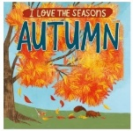  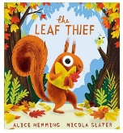  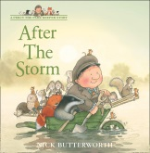 | Science  Art | RED Branch 1 Creation  The words and actions of the sign of the cross: ‘In the name of the Father, and of the Son and of the Holy Spirit. Amen’.  God created the world and said, ‘Indeed it is very good’ (Genesis 1:31).  The whole of Creation shows God love for us (Laudato Si’ 84–88).  God is love.  God made each one of us.  God loves each one of us as a unique person.  God made a wonderful world and what God creates is good.  God loves us and we are part of a family.  We enter God’s family, the Church, through baptism | Science:  (Seasonal Change)  I know that in Autumn the leaves change colour and fall from the trees  I know that animlas collect and store food in Autumn to prepare for Winter.  I know that conkers, pine cones and acorns fall from the trees in Autumn.  I can talk about what the weather is like in Autumn (wet/cold/windy)  (States of Matter)  I can talk about how ingredients change when they are mixed and cooked.  I know I cannot get back the ingredients once they have been combined  Art – Portraits (Drawing and Painting)  I know that Pablo Picasso was an artist who created abstract portraits  I know Pablo Picasso was born in Italy  I can create a portrait in the style of Pablo Picasso using paints and pastels
Autumn 2.a | Space | 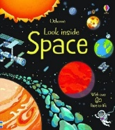  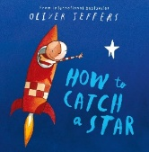  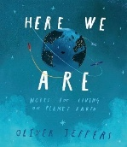  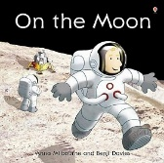 | Science  History  DT | RED Branch 2 Prophecy and Promise  I can recall key events from The Annunciation (Lk 1:26-31, 38). The Nativity (Lk 2: 4-7). The Shepherds visit the manger (Lk 2:8-20)  Mary was chosen by God to give birth to his Son.  Jesus was born in a stable and laid in a manger.  Shepherds were told by angels to visit him.  I know at Christmas, we celebrate the birth of Jesus  I can recall some key events from the Nativity story  I know how Catholics celebrate Christmas | Science  I know we live on planet earth  I can identify the Earth, moon, sun and stars  I know what an astronaut is  I know astronauts need a space suit to keep them safe in space  I know that you can only get to space in a rocket  I know that a rocket is pushed up by an engine  History  I know that there was a big war a ‘long time ago’  I know that every year we celebrate the day the war ended and remember people who died.  I can remember some key events from the gun powder plot story  DT – Structures – Art link 3D modelling  To explore and investigate the tools and materials in the junk area  To investigate cutting different materials  To learn how to plan and select the correct resources needed to make a model
Autumn 2.b | Winter | 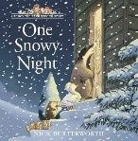  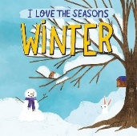  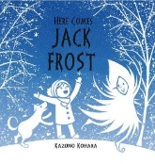 | Science  DT | RED Branch 2 Prophecy and Promise  I can recall key events from The Annunciation (Lk 1:26-31, 38). The Nativity (Lk 2: 4-7). The Shepherds visit the manger (Lk 2:8-20)  Mary was chosen by God to give birth to his Son.  Jesus was born in a stable and laid in a manger.  Shepherds were told by angels to visit him.  I know at Christmas, we celebrate the birth of Jesus  I can recall some key events from the Nativity story  I know how Catholics celebrate Christmas | Science  (Seasonal Change)  I know Winter comes after Autumn in the seasonal cycle  I can talk about what the weather is like in Autumn (wet/cold/windy)  I know that hibernate means staying as still as possible, using very little energy.  I know that some animals hibernate in Winter, I can name a few.  I know which clothes will keep my body safe and warm in Winter  I can talk about what the weather is like in Autumn (wet/cold/windy)  (States of Matter)  I know that when it is very cold, water will change to ice.  DT -Structures continued  To verbally plan and create a junk model  To share a finished model and talk about the processes in its creation .  To explore different ways to temporarily join materials together
Spring 1.a | People who help us  (in Wythenshawe) | 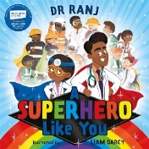  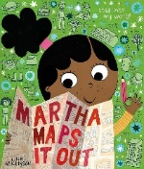  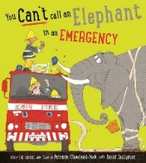 | Geography  Art | RED Branch 3 Galilee to Jerusalem  To believe that:  The Magi visited Jesus with gifts.  Jesus is God’s Son and came for everyone.  Jesus’ birth is celebrated at Christmas.  Jesus came to show God’s love and welcomes everyone.  Jesus takes care of everyone.  To know that the Church prays the ‘Glory Be’ as a response to the coming of Jesus.  To be able to recall key events from the following Bible passages:  The visit of the Magi (Matt 2:1-12).  Jesus blesses the little children (Mk 10:13-16). Feeding of 5000 (Jn 6:1-14 | Geography  I know I live in the UK  I know my school is in Wythenshawe, in a city called Manchester  I know some titles and roles of key adults in the community  I can draw a simple map  I can recognise and talk about some key features of Wythenshawe (Civic, Forum, police station, fire station, shops and the doctors)  Art (Printing)  I can recognise and talk about repeating patterns in the environment.  I can print using a variety of objects to make a repeating pattern  I can make a printing block using polystyrene and a pencil  I can recall some key facts about Andy Warhol  I can recognise some of Andy Warhol’s art work.
Spring 1.b | A Royal Adventure | 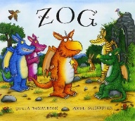  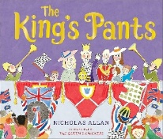  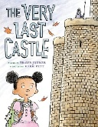 | History  Art  PSHE | RED Branch 3 Galilee to Jerusalem  To believe that:  The Magi visited Jesus with gifts.  Jesus is God’s Son and came for everyone.  Jesus’ birth is celebrated at Christmas.  Jesus came to show God’s love and welcomes everyone.  Jesus takes care of everyone.  To know that the Church prays the ‘Glory Be’ as a response to the coming of Jesus.  To be able to recall key events from the following Bible passages:  The visit of the Magi (Matt 2:1-12).  Jesus blesses the little children (Mk 10:13-16). Feeding of 5000 (Jn 6:1-14 | History  I know that castles were built a ‘long time ago’  I can name some features of a castle (moat, draw bridge, tower, turret)  I can compare compare old castles with modern houses  I know the current monarch is King Charles.  I know that before King Charles Queen Elizabeth was our monarch.  PSHE  I can identify five adults who I could talk to if I needed help.  I know that my pants are private and how to keep my body safe.  Art (Printing)  I can recognise and talk about repeating patterns in the environment.  I can print using a variety of objects to make a repeating pattern  I can make a printing block using polystyrene and a pencil  I can recall some key facts about Andy Warhol  I can recognise some of Andy Warhol’s art work.
Spring 2.a | Planting | 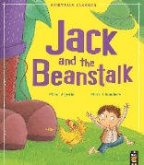  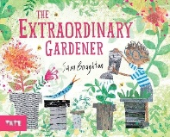  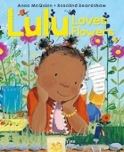 | Science  DT | RED Branch 4 Desert to Garden  To be able to recall key events from holly week including Good Friday and Easter Sunday.  I can listen to stories and talk about the season of Lent and Easter.  I believe Jesus died on Good Friday and rose again on Easter Sunday.  I know that Easter is a celebration that Jesus is with us still.  Easter celebrates new life.  I know that the Church uses purple and ashes as signs of Lent and being sorry.  To recognise representations of Holy Week and Easter: palms, the cross, Easter gardens, and symbols of new life  To be able to recall key events from the following Bible passages:  The great commandment (Lk 10:25-28) | Science  I know that plants grow from seeds.  I know that plants need soil, water and sunlight to grow.  I can name some key parts of a plant – root, stem, leaves.  I know that roots take water up to the plant  I can make observations of plants as the grow  DT Textiles  To develop threading and weaving skills  To practise and apply weaving skills to a specific material (paper, hessian and wool)  To use threading or sewing to design a product  To use textiles to create a product from their design  To reflect on how they achieved their aims.
Spring 2.b | Lifecycles | 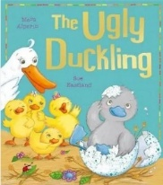    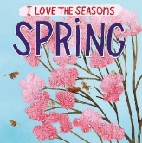 | Science  DT | RED Branch 4 Desert to Garden  To be able to recall key events from holly week including Good Friday and Easter Sunday.  I can listen to stories and talk about the season of Lent and Easter.  I believe Jesus died on Good Friday and rose again on Easter Sunday.  I know that Easter is a celebration that Jesus is with us still.  Easter celebrates new life.  I know that the Church uses purple and ashes as signs of Lent and being sorry.  To recognise representations of Holy Week and Easter: palms, the cross, Easter gardens, and symbols of new life  To be able to recall key events from the following Bible passages:  The great commandment (Lk 10:25-28) | Science  Seasonal Change  I know that in Spring the weather gets a bit warmer  I know that plants and flowers start to grow in spring  I know some baby animals are born in Spring and can name a few.  I know that buds start to grow on the trees in Spring  Lifecycles  I know that frogs begin life as an egg called Frogspawn  I know that a tadpole hatches from a frog’s egg.  I know that a tadpole turns in to a frog once fully grown  I know that ducks lay eggs  I know that ducklings are baby ducks  I know that ducklings hatch from duck eggs  I know that a duckling grows in to a duck.  DT Textiles  To develop threading and weaving skills  To practise and apply weaving skills to a specific material (paper, hessian and wool)  To use threading or sewing to design a product  To use textiles to create a product from their design  To reflect on how they achieved their aims.
Summer 1.a | Traditional Tales | 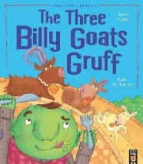  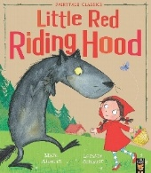  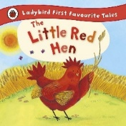 | PSHE  ART | Branch 5 – To the Ends of the Earth  Key Learning:  Story of Pentecost (Simple Telling).  The early Christian community (Acts 2:42-47)  Coming of the Holy Spirit at Pentecost.  The Good News of Jesus lived out by the early Christian community  Pentecost is a special celebration in the Church. Sunday is a special day for the Church to celebrate  The parish church and the parish family meet there to celebrate. | PSHE  I can talk about what makes a good friend.  I know that I should not talk to strangers unless one of my trusted adults has checked that it is okay.  I can name some trusted members of the community who can help me if I am lost (lolipop person, police officer, doctor, nurse, shop assistant)  Art (Drawing and Painting)  I can mix primary colours to create secondary colours (recap)  I can draw lines to enclose spaces and to represent different objects (recap)  I know that Steven Brown is an artist who creates colour pictures  I can recognise some of Steven Brown’s art work (McCoo paintings)  I can make different lines using a palette knife (Straight, wavy, zigzag)  I can paint and draw in the style of Steven Brown
Summer 1.b | Jungle | 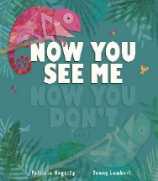  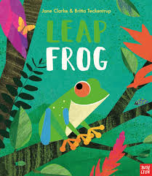  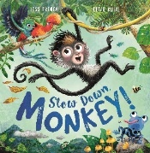 | Geography  Science  Art | Branch 5 – To the Ends of the Earth  Key Learning:  Story of Pentecost (Simple Telling).  The early Christian community (Acts 2:42-47)  Coming of the Holy Spirit at Pentecost.  The Good News of Jesus lived out by the early Christian community  Pentecost is a special celebration in the Church. Sunday is a special day for the Church to celebrate  The parish church and the parish family meet there to celebrate. | Science  I can name some animals that live in the jungle  I can sort animals according to their habitat (uk woodland or jungle)  Geography  I can identify a rainforest from images  I can identify key differences between wythenshawe and the Amazon rainforest  I know that the weather is hot and rainy in the Amazon Rainforest  Art (Drawing and Painting)  I know that Steven Brown is an artist who creates colour pictures  I can recognise some of Steven Brown’s art work (McCoo paintings)  I can make different lines using a palette knife (Straight, wavy, zigzag)  I can paint and draw in the style of Steven Brown
Summer 2.a | Summer | 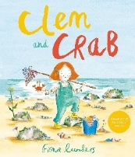  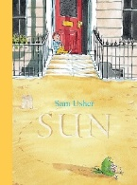  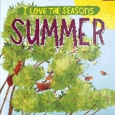 | Geography  Science  DT | RED Branch 6 Dialogue and Encounter  I know that Jesus lived in a place called Nazareth in Palestine.  I know that Jesus would have dressed like other people in Palestine  I know that Jesus would have had dark skin and hair as he was from Palestine.  I know some key events from the lives of St Peter and St Paul (link to their feast day)  I know that a priest’s role is to lead our church and to be a friend of Jesus  I can listen to people talk about their religions with respect and curiosity | Geography  I know some features of a seaside location – rock pools, sand, sea, deadwood, seaweed  I can talk about similarities and differences between the seaside and Wythenshawe.  I know why it is important to keep beaches rubbish free.  Science  I know that in Summer the weather gets warmer  I know how to keep myself safe in the sun.  I know some activities people like to do in the summer – going to the beach, eating ice cream, swimming.  I know how to dress in the summer.  DT  To understand what waterproof means and to test whether materials are water proof.  To test and make predictions for which materials float and sink  To compare the use of boats  To investigate how the shape and structure of boats affects the way they move.  To design a boat  To create a boat based on their design.
Summer 2.b | Under the Sea | 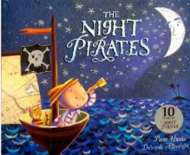  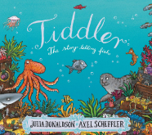   | Science  PSHE  DT | RED Branch 6 Dialogue and Encounter  I know that Jesus lived in a place called Nazareth in Palestine.  I know that Jesus would have dressed like other people in Palestine  I know that Jesus would have had dark skin and hair as he was from Palestine.  I know some key events from the lives of St Peter and St Paul (link to their feast day)  I know that a priest’s role is to lead our church and to be a friend of Jesus  I can listen to people talk about their religions with respect and curiosity | Science  I know some animals that live in the sea.  I can sort land and sea animals.  Know why it is important to keep the ocean habitat plastic free.  (continued from Summer 2.a unit)  PSHE  I can reflect on my achievements in Reception  I can build relationships with new people and adjust to a new classroom environment.  I can identify some things I would like to get better at in Year 1.  DT  To understand what waterproof means and to test whether materials are water proof.  To test and make predictions for which materials float and sink  To compare the use of boats  To investigate how the shape and structure of boats affects the way they move.  To design a boat  To create a boat based on their design.

*We teach art through explicit units covering drawing, painting and printing skills. 3D construction and collage skills are taught alongside the ‘Structures’ DT unit (junk modelling) and then through a range of adult led/play based learning activities throughout the year*

