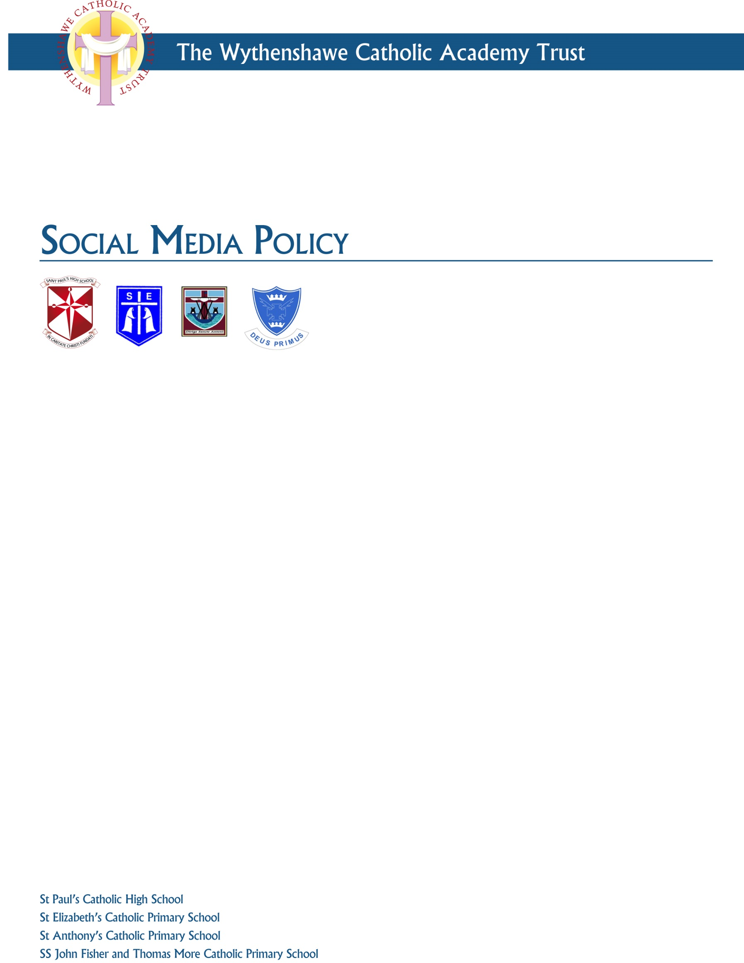

Document Record
Title | Social Media Policy
Date | March 2017
Supersedes | N/A
Purpose | To ensure that all adults working in school are aware of the Trust and school’s expectations and the rules they are expected to follow when using social media both inside and outside of the school environment.
Author | Wythenshawe Catholic Academy Trust
Review | April 2019
Date considered by WCAT | March 2016
Date consulted with unions | Not required
Date adopted by WCAT | 14 March 2016
Date distributed | 21 March 2016

Schools within the Wythenshawe Catholic Academy Trust:
- St Paul’s Catholic High School
- St Anthony’s Catholic Primary School
- St John Fisher and St Thomas More Catholic Primary School
- St Elizabeth’s Catholic Primary School

This policy will be published on the school’s internal web site under the staff section.

Contents

Paragraph Page

1. Introduction 4
2. Scope 4
3. Principles 6
4. Roles and responsibilities 6
- Headteacher 7
- Adults 7
5. Safer Social networking practice 7
6. Responsibilities when using social media 8
7. Accessing inappropriate images 11
8. School social media sites 11
9. Cyberbullying and trolling 12
- Cyberbullying 12
- Trolling 12
10. The Prevent Duty 12
11. Breaches of policy and other issues 13

- Introduction
  - The Wythenshawe Catholic Academy Trust (referred to hereafter as the Trust) recognises that new technologies are an integral and growing part of everyday life and that they make an important contribution to teaching and learning opportunities in school. This policy also recognises that in the light of the rapid evolution of social networking technologies, the school requires a robust policy framework so that all adults working in school are aware of the school’s expectations and the rules they are expected to follow when using social media both inside and outside of the school environment.
  - The Trust recognises many employees make use of social media in a personal capacity and expects that users of social media will be mindful that their right to freedom of expression attaches only to lawful conduct. Employees must always exercise their right to freedom of expression with due consideration to others and to reflect the Trust’s ethos and belief in the dignity of the individual.
  - This policy is designed to ensure that all adults use social media responsibly in order to safeguard the school, its students, staff, school governors and members of the wider school community. It is crucial that children are safeguarded and that parents, students and the public at large have confidence in the school’s decisions and services. Responsible use of social media will ensure that the confidentiality and privacy of students and members of staff are maintained and that the reputation and integrity of the school are protected.
  - The Trust appreciates that employees may make use of social media in a personal capacity. However, employees must be aware that if they are recognised from their profile as being associated with the Trust or a school within the Trust, opinions they express could be considered to reflect the Trust or school’s opinions. Employees must also be aware of any out-of-work social media activity which has the potential to cause embarrassment for the Trust may lead to reputational damage.
  - This policy takes into account the provisions of the DfE’s statutory advice for schools (July 2015) on Keeping Children Safe in Education, the non- statutory guidance from the UK Council for Child Internet Safety (UKCCIS), the non-statutory guidance on the Prevent Duty (June 2015), and the Briefing Note to schools on “How Social Media is used to encourage travel to Syria and Iraq”. It also takes into account the Government’s statutory guidance issued under s29 of the Counter -Terrorism and Security Act 2015 (June 2015).
- Scope of the policy
  - This policy applies to all employees who work at schools within the Trust. The schools in the Trust currently consist of St Paul’s Catholic High School, St Anthony’s Catholic Primary School, St John Fisher and St Thomas More Catholic Primary School and St Elizabeth’s Catholic Primary School.
  - This policy also applies to all adults working at schools within the Trust or provide services including self-employed staff, external consultants, agency staff, trainees, volunteers and governors.
  - This policy should be read in conjunction with other relevant school policies in particular, the school’s Safeguarding Policy, Code of Conduct, Disciplinary Policy, Grievance, Dignity at work Policy and Equality Policy.
  - Unless indicated otherwise, all references to “Governing Body” apply to school’s Local Governing Body or Interim Management Board.
  - This policy covers the personal use of social media as well as the use of social media for school purposes (whether official or not), including the use of websites hosted and maintained on behalf of the school or Trust.
  - This policy covers the use of social media as defined in paragraph 2vii of this policy and also personal blogs and any posts made on other people’s blogs and to all on line forums and notice boards. The guidance, rules and principles set out in this policy must be followed irrespective of the social media platform or medium.
  - In this policy, the following definitions apply:
- Social media - means any type of interactive online media that allows parties to communicate instantly with each other or to share data in a public forum. Social media includes but is not limited to, online social forums such as Twitter, Facebook and LinkedIn and also covers blogs, chatrooms, forums, podcasts and video-image-sharing websites such as YouTube, Flickr, Reddit, Instagram, WhatsApp, Snapchat and Tumblr. The internet is a fast moving technology and it is impossible to cover all examples of emerging social media in this policy.
- Adults/adults working in school - means all members of staff (including teaching and non-teaching staff) who work at schools and/or within the Trust as an employee or on a self-employed basis. It also includes trainee teachers, other trainees and apprentices, volunteers, agency staff, external consultants and school governors and anyone considered to be a representative of the school.
- Information - means all types of information including but not limited to, facts, data, comments, audio, video, photographs, images and any other form of online interaction.
- Inappropriate information - means information as defined above which any reasonable person would consider to be unsuitable or inappropriate in the circumstances and taking into account the adult’s position within the school.
- The school and the wider school community - means the Trust or any of the schools within the Trust, its students, all adults working in school (as defined above) parents/carers of students, former students, the Diocese of Shrewsbury and any other person or body directly or indirectly connected with the Wythenshawe Catholic Academy Trust.
- Principles
  - Adults have an important role to play in equipping the school’s students to stay safe online, both in school and outside of school. Adults therefore need to be aware of the risks associated with the use of social media and in particular about the provision and sharing of information in the social media arena.
  - Adults must not, whether deliberately or inadvertently and whether in their working time or in their personal time, provide, publish or share inappropriate information on or via any social media platform or medium about themselves, the school and the wider school community.
  - Adults are accountable for and must take responsibility for all information published or shared by them on social media websites and for any views expressed by them on any such sites, whether in their working time or in their personal time and which may come into the public domain. Adults should be aware that their use of social media and any information published by them may be monitored by the Trust, the Headteacher, members of the school’s senior leadership team and/or members of the school’s Governing Body. By using the school’s IT resources and facilities adults give the school consent to monitor their activities.
  - All adults who provide, publish or share information which causes harm or distress or which has the potential to cause harm or distress or to cause reputational damage to the school and the wider school community will be dealt with as appropriate by the Headteacher in accordance with the relevant Trust policy. This may include action being taken under the Trust’s Safeguarding Policy (which could lead to a referral to the Local Authority and/or the police) and it could also lead to disciplinary action being taken under the Trust’s Disciplinary Policy which, in serious cases may lead to dismissal without notice.
  - The principles which underpin this policy are:
- Adults are responsible for their own actions and behaviour and must avoid any conduct which would lead any reasonable person to question their motivation and intentions;
- Adults must be mindful at all times of the need to keep their personal and professional lives separate; adults must not put themselves in a position where there is a conflict between their work and personal interests;
- Adults must work and be seen to work, in an open and transparent way;
- Adults must continually monitor and review their own practices in terms of the continually evolving world of social networking and social media and ensure that they consistently follow the rules, principles and guidance contained in this policy.
- Roles and Responsibilities
- The Trust has delegated the overall responsibility for the effective operation of this policy, to the school’s Local Governing Body or Interim Management Board. The responsibility for the day to day management and operation of this policy has been delegated to the Headteacher.
- The Headteacher will:
- Ensure that all adults working in school are familiar with this policy and any related policies;
- Take all reasonable steps to enable adults working with students to work safely and responsibly and to support safer working practice in general with regard to the use of the internet and other communication technologies;
- Take all reasonable steps to assist adults to monitor their own practices and standards with regard to the use of the internet and other communication technologies;
- Set clear rules in relation to the expected standards of behaviour relevant to social networking for educational, personal or recreational use;
- Give a clear message that unlawful or unsafe behaviour or practice is unacceptable and that where appropriate, disciplinary, legal and/or other action will be taken;
- Ensure that all concerns raised in relation to the accessing of social media or social networking sites are investigated promptly and appropriately;
- Take all reasonable steps to minimise the risk of misplaced or malicious allegations being made against all adults working in school.
- Adults working within the Trust must:

- Ensure they are familiar with the contents of this policy;
- Adhere to and apply the rules, guidance and principles in this policy in all aspects of their work and in their personal time;
- Act in accordance with their duties and responsibilities under this policy and the statutory/non statutory advice and guidance referred to;
- Raise any concerns or queries in connection with this policy with the Headteacher;
- Attend any training provided or facilitated by the school in relation to the use of the internet or any other communication technologies.
- Safer Social Networking Practice
  - Adults must be aware of the risks and dangers of revealing personal information on social networking sites. Disclosing personal information about themselves or a colleague on social networking sites may compromise an adult’s personal safety and security as well as increasing the potential for identity theft by third parties. It can also increase the potential for students, their families or friends enabling access from adults outside the school environment to personal information. Personal information includes data such as a home address, home and mobile telephone numbers and details relating to their place of work.
  - Adults, particularly those new to the school setting, must review their social networking sites when they join the school and should ensure that they have the appropriate privacy settings in place to ensure that information available publicly about them is appropriate and accurate. This should include reviewing any photographs or images that may cause embarrassment to them or to the school and the wider school community.
- Responsibilities when using social media
  - Adults must take responsibility for their personal telephones and any personal electronic devices and must keep their personal telephone numbers, login details, passwords, pin details and personal email addresses private and secure.
  - Adults must take responsibility to ensure that their devices are not left unattended while logged in to prevent misuse by third parties.
  - Adults must understand who is allowed to view the content on their social media pages of any websites they use and how to restrict access to certain groups of people. Appropriate privacy settings are vital.
  - Adults must not request, or respond to a request for any personal information from or about a student at the school.
  - Adults must not engage in conversations about students with their parents or carers or with any other person by any form of social networking or social media unless they have the express permission of the Headteacher to do so.
  - Adults must not provide their personal telephones or email details on school business. Where there is a need for contact between students or parents or adults, school’s email address and telephone number must be used.
  - Adults must only use the official school website for communicating with students or to enable students to communicate with each other using authorised and previously agreed protocols. Any communications with students (including by email, telephone or text communications) outside agreed protocols will be treated as a very serious conduct matter and may lead to disciplinary action up to and including dismissal. It may also lead to a criminal investigation.
  - Adults must never “follow” or allow themselves to be “followed”, or make a “friend” of, or have any contact with a student at the school on any social networking site. The only exception to this rule is where the student is a member of the adult’s family and the family relationship has been identified to and acknowledged by the Headteacher.
  - In cases where a student is a family member, adults must be aware that if the family relationship has not been identified and acknowledged by the school, contact through social networking or social media will be a breach of this policy (and therefore will be treated as a serious conduct issue). Adults must be clear that such contact could also be misconstrued as being part of a grooming process. Since family relationships can be easily identified and recognised, adults must notify the Headteacher of any family relationship with a student so that the position can be formally acknowledged, discussed and recorded.
  - Adults must be cautious about any form of social networking contact with former students particularly where siblings or other relatives continue to attend the school or may attend the school in future.
  - Adults must be cautious about following or being followed by parents/carers of students, accepting parents of students as friends on Facebook or having contact with parents/carers on any social networking site. Adults must be mindful at all times of the boundaries between their work and personal life in accordance with the Key Principles detailed in this policy.
  - Adults must also be cautious when inviting work colleagues to be friends on social networking sites. Social networking sites can blur the boundaries between work and personal lives and it may be difficult to maintain professional relationships.
  - Adults must not use social media and the internet in any way to attack, insult, criticise, abuse or defame students, family members of students, colleagues, the Headteacher, governors, the Trust, the school in general and the wider school community. Adults must always show respect to others when using social media.
  - Adults must never post images, or links to images, that are discriminatory or offensive.
  - Adults must never post derogatory remarks or offensive comments on-line or engage in on-line activities which may bring them, the Trust, the school or the wider school community into disrepute or which could be interpreted as reflecting negatively on their professionalism.
  - Adults must never post offensive or derogatory comments relating to sex, gender reassignment, race (including nationality), disability, sexual orientation, religion or belief or age.
  - Adults must not represent their personal views on any social media forum as being in any way linked to the school or being the views of the school.
  - Photographs, videos or any other types of images of students and their families or images depicting staff members or where the school can be identified must not be published on social media.
  - Where social networking and other web-based sites have fields in the user profile relating to job title or information, adults, particularly teachers and teaching assistants, should not put any information onto the site which could identify the school or their role/profession at the school. In some circumstances the provision of such information could damage the reputation of the school and/or the relevant profession.
  - Teachers must at all times be mindful of the Teachers’ Standards applicable to their profession and act in accordance with those standards. The Teacher Standards make clear that a teacher must uphold public trust in the profession and maintain high standards of ethics and behaviour both within and outside of school, by ensuring that personal beliefs are not expressed in ways which exploit students’ vulnerability or might lead them to break the law. Any breach of the Teacher Standards will be considered a matter of misconduct and may lead to formal disciplinary action being taken.
  - Adults must devote the whole of their time and attention to their duties during working hours. Personal use of the internet is not permitted during working hours and any breach of this provision may be regarded as a conduct matter and disciplinary action may be taken as appropriate.
  - Confidentiality issues must be considered at all times in relation to social networking and the use of social media. All employees are bound by a common law duty of fidelity. There are also other laws which protect the school’s confidential information which adults working in school may have access to during the course of their work. Confidential information includes but is not limited to person identifiable information for example student and employee records, information protected by the Data Protection Act 1998 and information provided by the school in the expectation of confidence including information about the school, students and the families of students, the school’s staffing or business plans, and any other commercially or politically sensitive information.
  - Adults must ensure that they do not provide, publish share or otherwise disclose any confidential information about themselves or about the school and the wider school community in breach of their duty of fidelity or in breach of other laws relating to confidentiality and privacy including the Human Rights Act 1998, and the Data Protection Act 1998.
  - Adults must ensure they understand their obligations under the Equality Act 2010 and under the school’s Equality Policy. Breaches of the Equality Act 2010 or the school’s Equality Policy through the use of social networking or social media will be considered a serious conduct matter which may lead to disciplinary action up to and including dismissal. Adults should also be aware that they could be held personally liable for their own discriminatory actions under the Equality Act 2010. If, for example an adult was to harass a co-worker online or engage in a discriminatory act in relation to one of the protected characteristics under the Equality Act 2010, this may result in legal action being taken against them.
  - Adults should also be aware that there are other laws relating to libel, defamation, harassment and copyright which may apply to information, published or posted by them on social media and which could lead to legal action being taken against them. The laws of defamation and apply to statements which:
- Expose (an individual) to hatred, ridicule or contempt;
- Cause (an individual) to be shunned or avoided;
- Lower (an individual’s) standing in the estimation of right-thinking members of society or;
- Disparage (an individual in their) business, trade, office or profession.
  - All concerns about communications, social contact or social media/social networking issues must be raised with the Headteacher immediately.
- Access to inappropriate images
- There are no circumstances which justify adults possessing indecent images of children whether in working time or in an adult’s personal time. Adults who access or possess links to such material or websites will be viewed as a significant and potential threat of harm to children. Appropriate action will be taken against the adult concerned in these circumstances which, for the avoidance of doubt, could include action under the school’s Safeguarding Policy (which could lead to police and Local Authority involvement) and disciplinary action (which could result in dismissal without notice on the grounds of gross misconduct). Where indecent images of children are found by any adult, the Headteacher must be informed immediately.
- Adults must not use equipment belonging to the school to access pornography or adult or explicit material of any kind. Personal equipment containing these images or links to them must not be brought into school. If any adult uses school equipment or personal equipment in school to access pornography or links to it, this will raise serious concerns about the suitability of the adult concerned to work with students. This will lead to an investigation and may lead to disciplinary action and any other action considered appropriate in the circumstances.
- Adults must ensure that students are not exposed to any inappropriate information, images or web links. The school will endeavour to ensure that internet equipment used by students has the appropriate controls with regards to access. Any concerns or potential issues identified by any adult must be reported immediately to the Headteacher.
- Where any form of unsuitable material is found, which may not be illegal but which could raise concerns about an adult working in school, the Headteacher should be informed immediately. The Headteacher may take HR or legal advice on the appropriate way forward.
- School social media websites
  - There must be a strong pedagogical or business reason for creating an official school social media/social networking website including websites to communicate with students. Adults must not create websites for reasons which could expose the school to unwelcome publicity or which could cause reputational damage to the Trust or the school. The matter must have been discussed, authorised and agreed with the Headteacher in advance of any school website, including social media websites, being created.
  - Adults must at all times act in the best interests of the school and the students when creating, participating in or contributing to the content of any website created on behalf of the school.
- Cyberbullying and trolling
- Cyberbullying
- Cyberbullying can be defined as ‘the use of modern communication technologies to embarrass, humiliate, threaten or intimidate an individual in the attempt to gain power and control over them.’
- If cyberbullying takes place, adults should keep records of the abuse, texts, e-mails, website or instant messages and should not delete the said texts, e-mails or messages. Adults are advised to take screen prints of messages or web pages and to be careful to record the time, date and location of the site.
- Trolling
- Trolling can be defined as ‘circumstances where a person sows discord on the internet by starting arguments or upsetting people by posting inflammatory messages in an online community with the deliberate intent of provoking readers into an emotional response’;
- If trolling occurs, adults are advised to take screen prints of messages and should not delete any evidence of trolling.
- Adults must report all incidents of cyberbullying or trolling to the Headteacher. Any such incidents will be taken very seriously. Adults who have been subjected to cyberbullying or trolling may wish to seek the support of their trade union or professional association representative.
- The Prevent Duty
  - Schools have a vital role to play in equipping children and young people to stay safe online, both in and outside school and also in protecting students from the risks of extremism and radicalisation. Section 26 of the Counter-Terrorism and Security Act 2015 places a duty on specified authorities, (including schools) in the exercise of their functions, to have due regard to the need to prevent people from being drawn into terrorism (the Prevent Duty).
  - Terrorist organisations, such as IS, are attempting to radicalise and recruit young people through extensive use of social media and the internet. As with any other online risks of harm, every adult in school (teachers and teaching assistants in particular) must be aware of the risks posed by the online activity of extremist and terrorist groups.
  - The Government has issued statutory guidance in relation to the Prevent Duty (June 2015). In addition, to assist schools and to help recipients understand the implications of the duty, the Department for Education (DfE) has also produced non statutory advice (June 2015). Adults should familiarise themselves with the guidance and the advice, both of which are available on the school website.
  - The statutory guidance makes clear the need for schools to ensure that children are safe from terrorist and extremist material when accessing the internet in schools. The school will ensure that suitable filtering is in place. Internet safety is integral to the school’s ICT curriculum and the school will ensure it is embedded in the school curriculum. In addition to advice on internet safety provided by the school, further general advice and resources for schools on internet safety are available on the UK Safer Internet Centre website.
  - Keeping children safe from risks posed by terrorist exploitation of social media should be approached by adults in school in the same way as safeguarding children from any other form of online abuse. The DfE has produced a briefing note aimed mainly at Headteachers, teachers and safeguarding leads in schools detailing how social media platforms are being used in particular to encourage travel to Syria and Iraq. All adults in school (teachers and teaching assistants in particular), should familiarise themselves with the contents of the briefing note and must ensure that if they have any concerns, the school’s normal safeguarding procedures are followed. The Briefing Note is available on the staff share folder / in the school office/on the school intranet / website.
  - For the avoidance of doubt, if any adult working in school has a concern that a particular student or group of students is at risk of radicalisation or terrorist exploitation, through social media or otherwise, they must immediately contact the Headteacher and follow the school’s normal safeguarding procedures, including discussing the matter with the school’s designated safeguarding lead and where deemed necessary, with children’s social care at the Local Authority and the local police.
- Breaches of Policy and other issues
- Any breach of this policy and the duties, responsibilities, professional standards and legal obligations referred to will be regarded as a serious matter and action including disciplinary action in appropriate circumstances will be taken by the Headteacher (or the Governing Body). In serious cases involving employees this may lead to dismissal without notice on the grounds of gross misconduct.
- Where there has been a breach of this policy, the school will also take whatever action is considered appropriate in order to protect the reputation and integrity of the school and the wider school community.
- Adults must be aware that any breach of this policy involving a breach of the laws, professional codes or other statutory provisions referred to in this policy may result in legal or other action being taken against them by a body or person other than the school.

